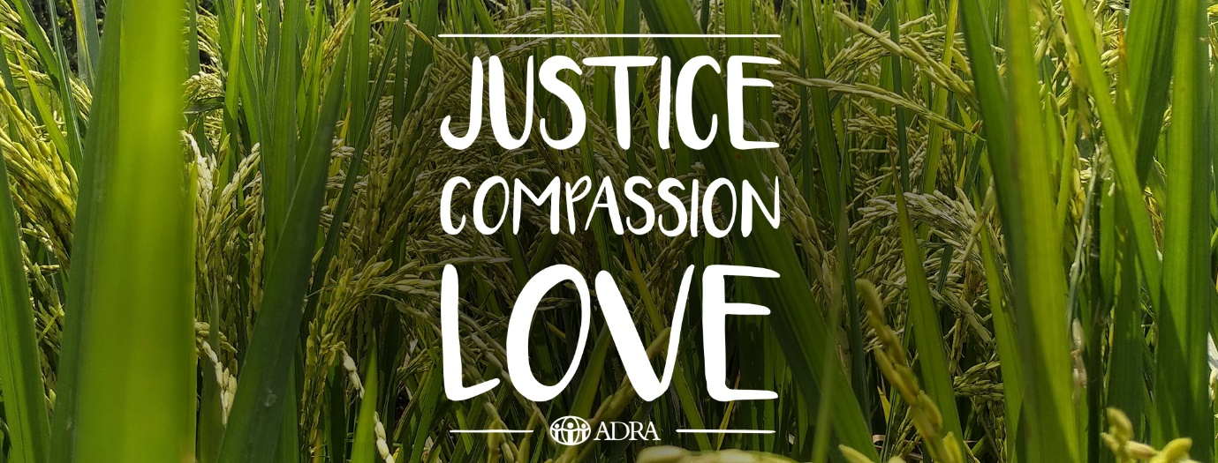

Why ADRA?

ADRA’s Purpose Statement:

“Serving Humanity so all may live as God intended, free from poverty and disadvantage”

Fuelled by faith and guided by prayer, ADRA has served our brothers and sisters for over 60 years.
When our pioneers started packing supplies for families in 1956, our belief in people was the same as it is now:

All people were created by God to thrive.

It’s a simple approach to serving humanity but one that now spans the globe, impacting lives in more than 130 countries. No matter the location, language or challenge, we strive for the same thing – a world in which all people may live life as God intended.

A life filled abundantly with justice, compassion, and love.

Justice, so that every action is chosen for the impact it will have on others. We are called to an understanding that every child of God deserves not only the necessities of food, water and shelter, but the opportunity to be the unique individual they were created to be.

Compassion, because Christ compels us (2 Corinthians 5:14). No one should carry their burden alone.
A commitment to serving others with compassion - brings the best out in yourself, and those around you.

And love. The God who calls us asks for a love with no limitations, a love so strong that all may see the reflection of God’s character in our service, and a love that is made real through actions, big and small, worldwide and at home, defined by compassion.

Justice. Compassion. Love.
God called all to these three things in Micah 6:8. We live it, so others may have it. We share it, so
it too can be shared.

7 reasons + 7 testimonies:

- Part of a local network of like-minded Adventists. This provides economies of scale to support each other’s centres with prayer, resources, training and governance.
- Part of a global network. This creates opportunities for increased awareness, funding and support. (for example: Funding received from ADRA International and ADRA Australia Op Shops to support the COVID-19 response)
- ADRA breaks down barriers between local communities and Adventists. Community members get to see Adventists as people who are genuinely interested in their well-being, and Adventists get to understand and help their neighbours in practical and holistic ways. (Christ’s Method Alone)
- Accredited and a member of the Australian Council for International Development (ACFID), Department of Foreign Affairs and Trade (DFAT), Fundraising Institute Australia (FIA), Micah Challenge and the Church Agencies Network (CAN). This means our programs are developed to meet professional industry standards and governance protocols. ADRA provides access and training to resources for operating your project in line with industry standards across work health and safety, financial and human resources.
- Better together than independent… helps when conducting ADRA appeal, economies of scale, public relations, supporting one another with the ADRA prayer network and government support.
- Seed funding and access to deductible gift recipient status for tax deductions.
- Dual branding with SDA church on flyers (see below) and uniforms with Justice Compassion and Love branding.

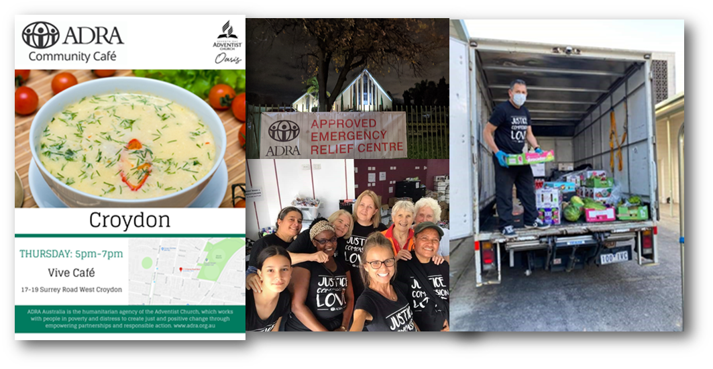

7 testimonies:
- It has been & continues to be an amazing, rewarding, faith affirming experience. Running the new Food Hub at Wantirna has been an incredibly busy time and I've had a huge learning curve as we definitely started running before we could crawl. The support that we have had from Sue (ADRA FTG) & BB (ADRA Casey) in particular has been incredible. We've just hit 30 families that we deliver to weekly. We've been very intentional in trying to develop relationships with our clients, through weekly phone calls & weekly deliveries by the same driver. We are trying to meet not just their physical needs but also their spiritual needs. Each week as they share some of their struggles with me, I ask if they would like us to pray for them. We pick 3 particular clients each week & start our packing day on a Thursday praying for them as a team & then we all pray for each of them all week. It's been lovely to hear from our clients that we make them feel valued & cared for and that they've never been treated like this by a care agency. I have approximately 25 weekly volunteers from our Church & monetary support from other Church members who can't help physically. One of our Church members donated money to buy a computer for one of our client's child - a 13y.o boy with Aspergers. We ran a Winter Warmers Appeal for FTG and Sue almost cried when we delivered 12 bags of jackets, Fleecy track suits, wet weather jackets & 40 pairs of thick explorer socks - 90% of it was new & bought for some of her homeless clients in particular. I have just seen so much generosity and I have never felt God more present. Every week, sometimes every day, He provides for our client's needs. Sometimes I've just started thinking - maybe I need someone to do a particular job & before I can ask somebody my phone will ring with someone offering to do anything I want. It's absolutely magical. Another instance: I was in a KERN Meeting & so was a rep from Foodbank (this is the first meeting they've been at in over 12 months). Kate said, “Liz you've just put in application to get access to Foodbank?” I said yes & she asked if she could call me after the meeting, which she did. She proceeded to tell me they weren't taking on any new partners because they can't do a site inspection but she said she would make an exception for me as she has huge respect for you Bec & all of the ADRA sites. I was ecstatic. God just keeps providing. My Church just keeps providing more support & my new ADRA family just keep sharing & supporting us. Liz Heath: Wantirna SDA Church (New project started May 2020)

- We’ve started the ADRA Café in June 2020 at Dandenong Polish SDA Church. Prior to this our church was never directly responsible for a project like this. Given the climate of 2020 and the restrictions that took place we had no idea how this project would take off. On our opening night we had 15 visitors. Now 2 months later and with Stage 4 restrictions we are the only program operating in our area and have close to 60 people attend weekly. We not only provide hot meals and food hampers but also support people with clothing and other house items where possible. We have started serving hot soup on Wednesday nights to meet the demands of the local community within the stage 4 restrictions. We feel that God is blessing this project from every angle. People have been very generous with donations which has allowed us to purchase necessary equipment (i.e. 2 large freezers) to run such a project at the scale it's growing. Also we have more than 40 volunteers that commit their time on a weekly basis to serve the most vulnerable in our community. ADRA Victoria has been supporting us on the side lines from the beginning and provided us with advice and essential tools needed to launch this project. We thank GOD for HIS ongoing guidance and blessings. And as it states in Ephesians 3. 20 “Now all Glory to God, who is able, through his mighty power at work within us, to accomplish infinitely more that we might ask or think” Wojtek Klauza – Dandenong Polish SDA Church (New project started June 2020)

- In the bible we read how God’s light shines through even in the darkest of times. Covid19 has brought uncertainty and darkness in 2020, but God’s light shines brighter. As a church group we were called to serve our community as a relief response. Our street feeding program has been running for over 2 months now. Every Friday night we hand-out over 150 meals, hot cups of soup, assorted grocery items, clothes, blankets and sanitary packs to less fortunate people in our community of Dandenong. It is a vulnerable time for many. Each week we hear stories of people who have lost their job, unable to pay rent, struggling to cope with everyday expenses and can’t find a place to live. Furthermore, most aid organisations in the area have had to stop due to government restrictions. This means less help for people in unfortunate circumstances. However, God is good! He continually shows us how much He loves those in need by allowing us to be there for our community and empowering us to provide essential assistance at this time. Especially how God works to lead people to us. Each week, a new friend or contact and never short of what is needed. Janelle Bocola – Dandenong Filipino SDA Church (New Project started June 2020)

- I have found Matthew 11:28-30 to be fundamental to the work that we do: “Come to me all who are burdened, take my yoke upon you and I will give you rest.” How easy it is to experience the distress individuals and the world experiences. How easy it is to be overcome with grief and dare I say trauma, when we see widespread destruction, sickness and death in our communities. Indeed the thought alone breaks my heart. True rest comes from Jesus! Instead of placing the extraordinary burden upon us, He invites us into a warm embrace and although we may still feel some of that burden, He says my yoke - that indicates a shared responsibility in the work that we do, with the savior of all humanity! - is easy and light. What relief to have such support and absolutely critical to communicate to the people around us. To maintain our composure when the odds are against us and trust in Jesus. Sure, we’re not perfect, we don’t always get it right and we use the resources and skills available to us, but our faith is not misplaced and that’s the point. Jesus is the point, the sharp end of the spear. This is the advantage of longstanding relationships with our community, donors and volunteers. We can demonstrate that when the going gets tough, we’ll be in the thick of it beside our community. This is why I love what I do and why I persevere. Because Jesus is the point. Leslie Baul – Oasis SDA Church (Project since 2010)

- Have just noticed that many recipients of our food hampers have never before in their lives had to ask for help. They've found asking for help hard, but also challenging finding out where and who they can ask for help from. COVID unemployment or underemployment has had the most impact with families, asylum seekers and international university students being the most affected. Why do I help ADRA? Giving food is an easy job but it's just one way to be Jesus' hands and feet, and to show people that we care about them! Donna Pascoe – Plenty Valley SDA Church (Project since 2010)

- Whittlesea Community Connections (WCC) has been working in partnership with ADRA Plenty Valley for many years now and WCC truly values and appreciates the support that ADRA provides to our mutual clients. ADRA provides an incredibly unique and specialised emergency relief support to vulnerable community members through the delivery of a specialised grocery shop that is tailored to suit clients specific needs i.e. culturally appropriate food, dietary requirements or simply access to items such as baby formula or nappies that a client may not be able to access from another emergency relief service. Further these hampers are always delivered in a timely manner that responds to the urgency of the clients need for support. Over the 3 years that I have been at WCC I have only ever received really positive and grateful feedback from clients regarding the hampers they have received from ADRA. Many clients have told us that the hampers are incredibly lovely and well thought out in terms of what is provided. Further client feedback regarding the volunteers who deliver theses hampers has always been positive as well which makes a huge difference to the clients who receive ADRA support. ADRA has played a really key role in providing emergency relief support to community living in the City of Whittlesea and also through the partnership with the Emergency Relief Network. Further ADRA has provided vital specialised support to clients throughout this current Covid-19 pandemic and continue to do so making a really big difference in the lives of the clients who receive ADRAs hampers. Ginette Beguely - Emergency Relief Coordinator/Caseworker – Whittlesea Community Connections.

- Last Monday at our ADRA Food pantry, it was a freezing, cold, wet and windy day. By 2pm we had got our delivery drivers off, dodged the rain to help people put food packages in their cars. I was just helping a disabled man with a can of emergency fuel that I had gone to give him, when an old van spluttered into the car park. A sliver of a girl climbed out of the car and hurried in the rain to our reception area. Upon talking with her, Perri our receptionist came and got me to help. She, *Amanda, stood shivering, under cover at the front door of our Church, (unable to come inside because of COVID), and shyly asked for help. I took a deep breath, offered a quick prayer up, and asked what her greatest need was. *Amanda, lifted her foot and showed me her boot. There was a gaping hole in her boot, the upper and sole were parting and I could see that her sock was wet. The other boot wasn't much better. Our other clients were coming and going, as Amanda stood aside, trying to be invisible and keep out of the way. We dispatched one of the team to get Amanda a hot drink and something to eat, someone else to check the clothing store, the rest continued to serve as I consulted with Perri. We moved things in reception, sanitised (made COVID safe) and brought Amanda inside into that area. Jodie, a team member, came back and reported we had NOTHING in size 10 shoes, but she was armed with warm clothes, socks and jackets. Mel had a box of underwear for Amanda to check for size. Ummm, Size 10. Ahh, wonderful, I thought. My daughter and Granddaughter were both size 10 and they only live 10 minutes away. I rang and passed a message of what we needed, could they help. She rang back after 10 minutes, in a break from teaching her prep class. I zipped over to her house and picked up a parcel of sneakers, jumpers and, as my daughter explained, a special bag, with a personal gift for her. Arriving back at the Church, a different Amanda was sitting in the reception area. She had colour in her face, was dressed in a fuzzy warm jacket and track suit pants, with her hands wrapped around a hot drink. She gave me a shy smile, her eyes still wet with unshed tears. The sneakers fitted, she pulled out a lovely jumper and matching cashmere wrap from the parcel, and hugged them to her chest. They were so lovely. I gave her the little present to unwrap, telling her that this was a gift for her. A gift to show her someone cared, and that God cared too. It was a lovely ring and earrings matching the colour of the scarf. She burst into sobs. I forgot COVID protocol and hugged her while she cried. All our staff was crying as well, even tough Bolle had a tear. At the end of the day, we were physically drained, but strangely energized. Most of our FTG staff are former clients, and they knew how it felt to be in Amanda’s wet boots! They recognized that they COULD make a difference in people's life.
PS Our clothing cupboard was well stocked because our sister Church, Wantirna had donated some of their fabulous "Winter Warmer Drive" clothes to us. New rain Jackets, socks, track pants etc., some of which were just right for Amanda. Definitely, all things work together for those who Love, (serve) the LORD.
And... that's why I love serving at ADRA.
Sue Beament – Ferntree Gully SDA Church (Project since 1959)

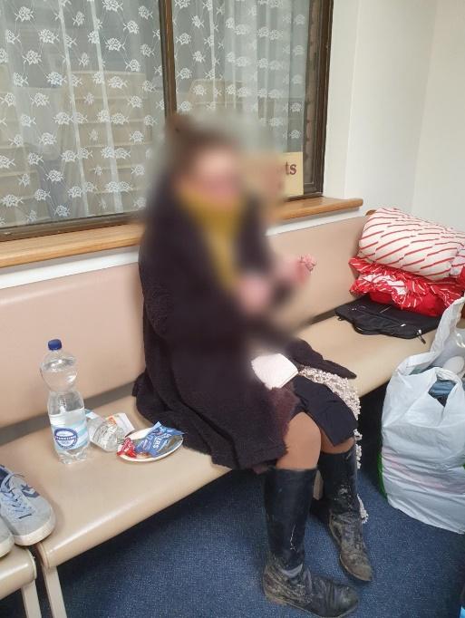
*Amanda on Monday, 24th August 2020. Name changed to protect privacy.

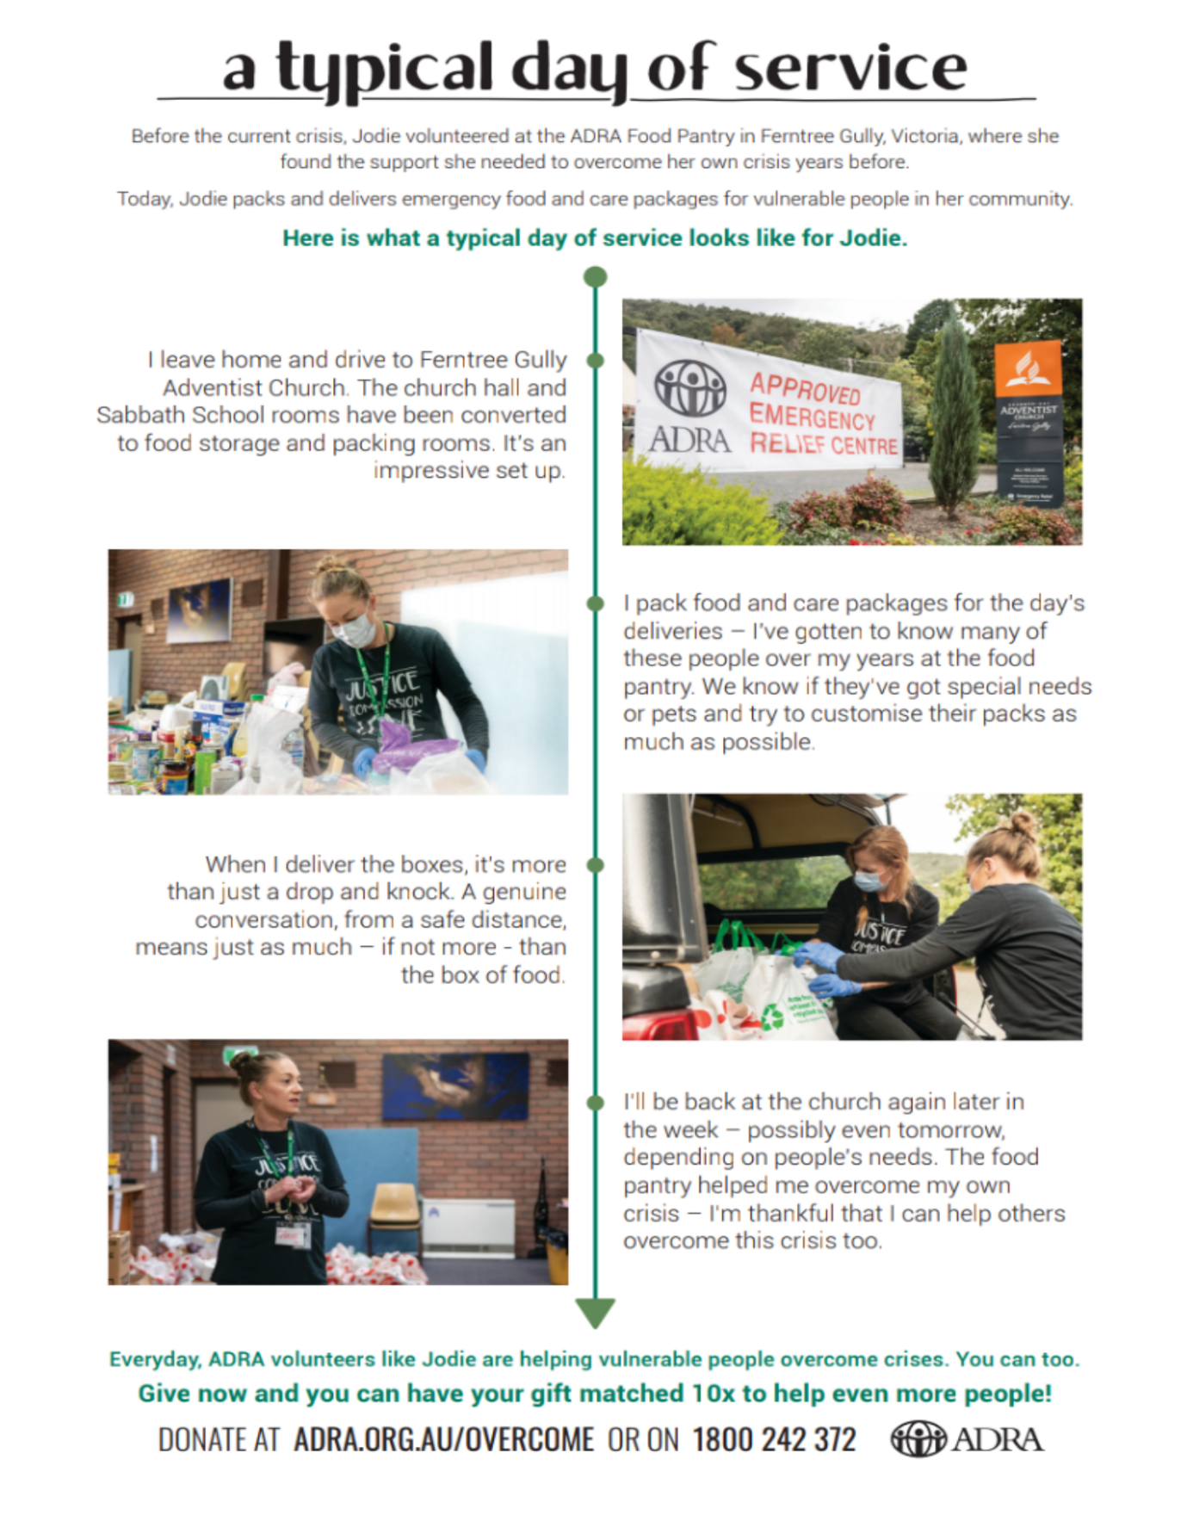

Email your Conference ADRA Director – Rebecca Auriant to get started today! rauriant@adra.org.au

