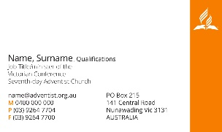
Business Card Template
Please fill in the required fields and we will return a completed print package for you to send to your printer

Title

Name

Qualifications

Position

Email

Mobile
Other phone number if required

Fax number if required
Other – eg facebook, twitter,

Please indicate:

- Do you want the back of the card orange with the Logo Seventh-day Adventist Church Victoria and the words “A thriving disciple-making movement”

- OR plain white so you can write on it if needed

- OR some other wording/image on the back
- Please supply wording and email other possible graphics

For pastors:
Do you want your church name and address on front of your card ? If yes, please supply:

Do you want your church website on your card ? If yes, please supply:

On the back of the card, if you are keeping it orange with the logo, would you like your church name to appear instead of Victoria? Please indicate Y/N

If your business card is generic, not church specific, or if your church does not yet have
one, would you like the conference website on your card? Please indicate Y/N

Is there anything else unique you would like if we can accommodate it?

Please complete form and return to KarinaGurban@Adventist.org.au

